**Power-saving techniques for the Atmega328P processor.**

**Summary of methods**

Run the processor at a lower frequency 🡪 We could change the FOSC (8Mhz)

Run the processor at a lower voltage 🡪 With a LDO regulator we will run the end-device at 3.3V

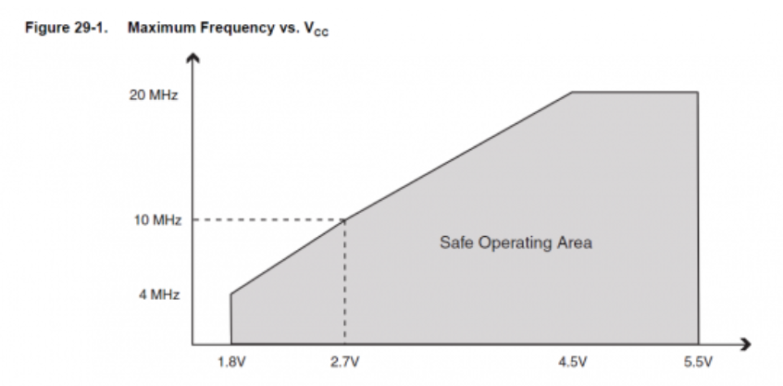

Turn off unneeded internal modules in software (eg. SPI, I2C, Serial, ADC)

#include <avr/power.h> LIBRARY

**Enabling:**

power_adc_enable(); // ADC converter

power_spi_enable(); // SPI

power_usart0_enable(); // Serial (USART)

power_timer0_enable(); // Timer 0

power_timer1_enable(); // Timer 1

power_timer2_enable(); // Timer 2

power_twi_enable(); // TWI (I2C)

**Disabling:**

power_adc_disable(); // ADC converter

power_spi_disable(); // SPI

power_usart0_disable();// Serial (USART)

power_timer0_disable();// Timer 0

power_timer1_disable();// Timer 1

power_timer2_disable();// Timer 2

power_twi_disable(); // TWI (I2C)

**POWER DOWN SLEEP TO SAVE ENERGY**

The sleep modes differ in what parts remain active, by the sleep duration and the time needed to wake-up (wake-up period).

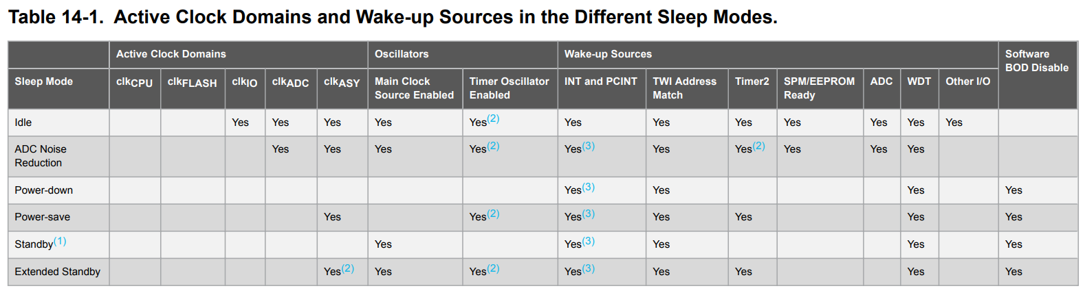

Library # include <avr/sleep.h>

Library #include <avr/wdt.h>

**XBEE considerations for using sleep mode.**

Three different sleep modes supported:

Pin sleep (SM = 1)

Cyclic sleep (SM = 4)

Cyclic sleep with pin wake-up (SM = 5)

When the module enters sleep mode:

The module de-asserts (low) the On/Sleep pin (pin 13) to indicate the module is entering sleep

mode.

The Sleep_RQ pin (pin 9) is configured as a pulled-down input so that an external device can

drive it high to wake the module (only applies to SM = 1 or SM = 5).

When the XBee wakes from sleep:

The device asserts (high) On/Sleep pin to indicate the device is awake.

**Pin Sleep MODE:**

Pin sleep allows an external microcontroller to determine when the XBee should sleep and when it

should wake by controlling the Sleep_RQ pin (pin 9). When Sleep_RQ is asserted (high) by connecting it to 3.3 volts, the module finishes any operation and enters a low power state. The module wakes when the Sleep_RQ pin is de-asserted (low).

Enable pin sleep mode by setting the Sleep Mode (**SM**) parameter to Pin Hibernate [1].

**Cyclic sleep:**

Cyclic sleep allows the module to sleep for a specified time and wake for a short time to poll its parent for any buffered data messages before returning to sleep again.

**Cyclic sleep with pin wake-up**

It’s a slight variation of the cyclic sleep mode that allows the module to bewoken prematurely by de-asserting the Sleep_RQ pin.